

WIA3007 DATA MINING AND WAREHOUSING

Semester 1 Session 2019/2020

Red Wine Quality

**MILESTONES 2**

SAS SEMMA

NAME:

1. MUHAMMAD SHAZWAR BIN ANUAR (WIE160015)
2. MOHAMAD AIMAN ARIF BIN MOHAMAT SAAT (WIE160010)

LECTURER:

PROFESOR DR. TEH YING WAH

**Table of Contents**

|  |  |
| --- | --- |
| **Title** | **Page** |
| 1. Introduction | 3 |
| 1. Data source | 4 |
| 1. Explore | 6 |
| 1. Replacement | 19 |
| 1. Cluster | 25 |
| 1. Data partition | 28 |
| 1. Decision Tree | 31 |
| 1. Model Comparison | 38 |
| 1. References | 39 |

**1 Introduction**

SAS Institute defines data mining as the process of Sampling, Exploring, Modifying, Modelling, and Assessing **(SEMMA)** large amounts of data to uncover previously unknown patterns which can be utilized as a business advantage. The data mining process is applicable across a variety of industries and provides methodologies for such diverse business problems as fraud detection, householding, customer retention and attrition, database marketing, market segmentation, risk analysis, affinity analysis, customer satisfaction, bankruptcy prediction, and portfolio analysis. SEMMA data mining process can be described as **Sample** for sampling of data by creating one or more data tables. The samples should be large enough to contain the significant information, but small enough to process. **Explore** for exploring data by searching for anticipated relationships, unanticipated trends, and anomalies in order to gain understanding and ideas. **Modify** process is where data is modified by creating, selecting, and transforming the variables to focus the model selection process. **Model** is created by using the analytical tools to search for a combination of the data that reliably predict a desired outcome and **Assess** is a process where you assess competing predictive models such build charts to evaluate the usefulness and reliability of the findings from the data mining process. In this assignment, the task was focused on the first two characters of SAS SEMMA which is S and E.

**2 Data Source**

Data source that we used in this assignment is Wine Quality Data Set from UCI Machine Learning Repository. Using red wine samples, the inputs include objective tests (e.g. PH values). The output is based on sensory data (median of at least 3 evaluations made by wine experts). Each expert graded the wine quality between 0 (very bad) and 10 (very excellent). These datasets can be viewed as classification or regression tasks. Number of Instances of red wine is 1599 and the number of attributes is 12.

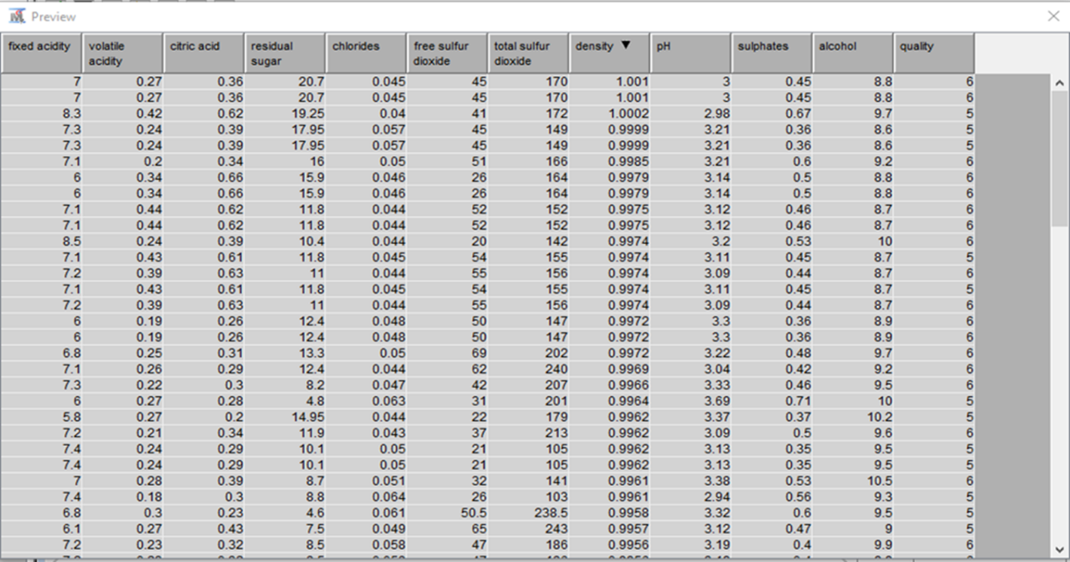

*Figure 1 show the preview of the Redwine quality dataset*

**2.1 Metadata**

The dataset consists of 12 attributes. The *Quality* attribute is used as the target label.

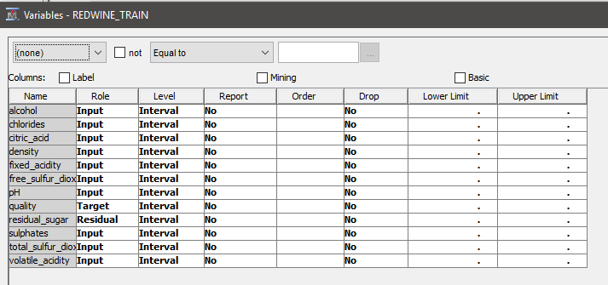

*Figure 2 show the metadata about the Redwine dataset*

**2.2 Analysis Goal**

* To identify the best and the worse red wine
  1. **Analysis Data**
* Extracted from the red wine research
* Inputs include objective tests (e.g. PH values)
* The output is based on sensory data (median of at least 3 evaluations made by wine experts)

**3 Explore Part 2**

**3.1 Graph**

Basic exploration is done to gain the first view of data.

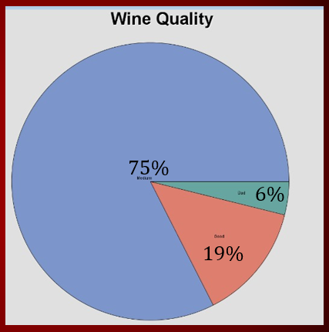

*Figure 3 Pie chart of Target variable.*

As shown in Figure 3, the data is shows that 75% of the quality of red wine in the dataset is average quality. Then, the good quality gets 19% and followed by bad quality, which is 6%.

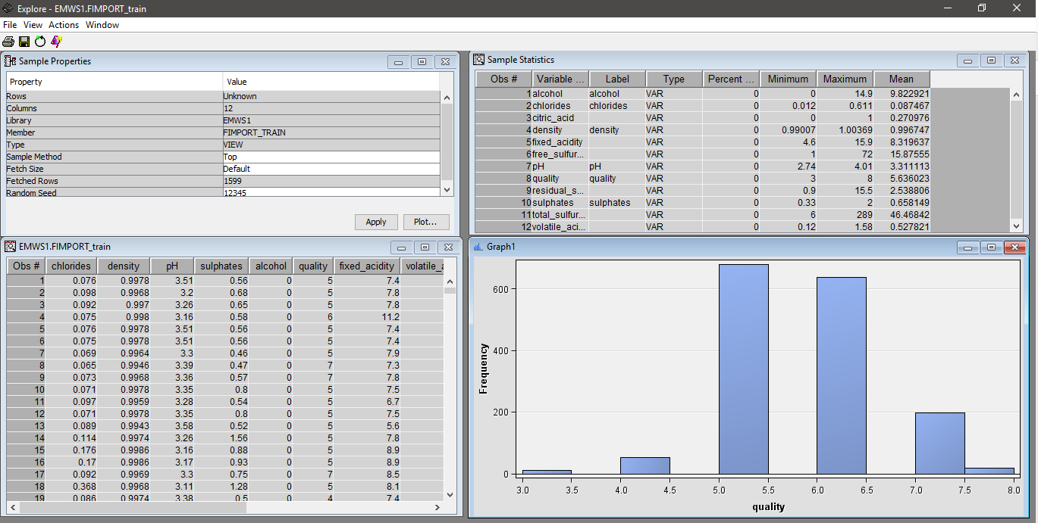

*Figure 4 Exploration of Target variable.*

Figure 4 shows the exploration of Target variable *Quality*.

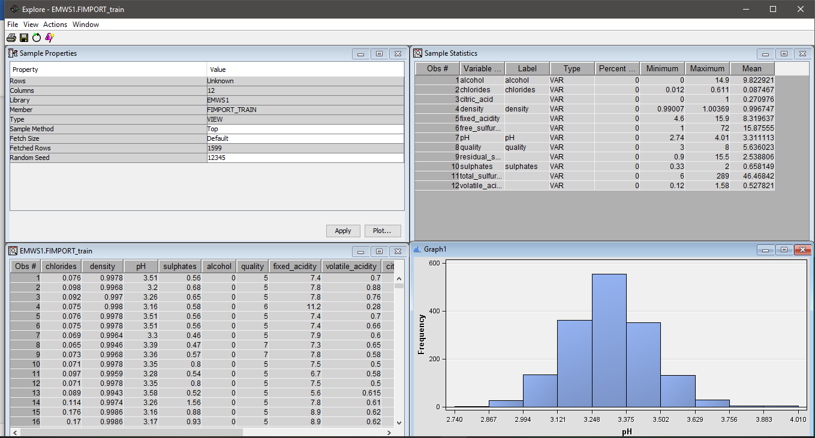

*Figure 5 Example exploration of one of the many attributes.*

Figure 5 shows exploration on other attributes

**3.2 Attributes Exploration**

1. Attribute: Chloride

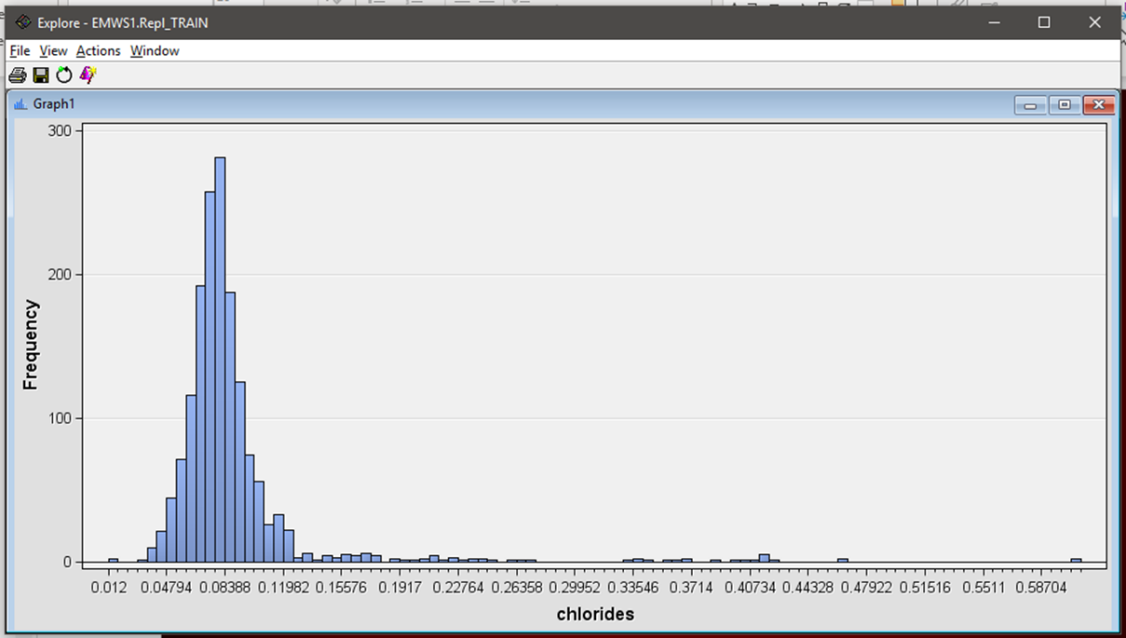

*Figure 6 Example exploration of chloride attributes.*

Figure 6 shows exploration on chloride attributes ranging from 0.012 until 0.6. Most of the sample have chloride value of 0.8388.

1. Attribute: Alcohol

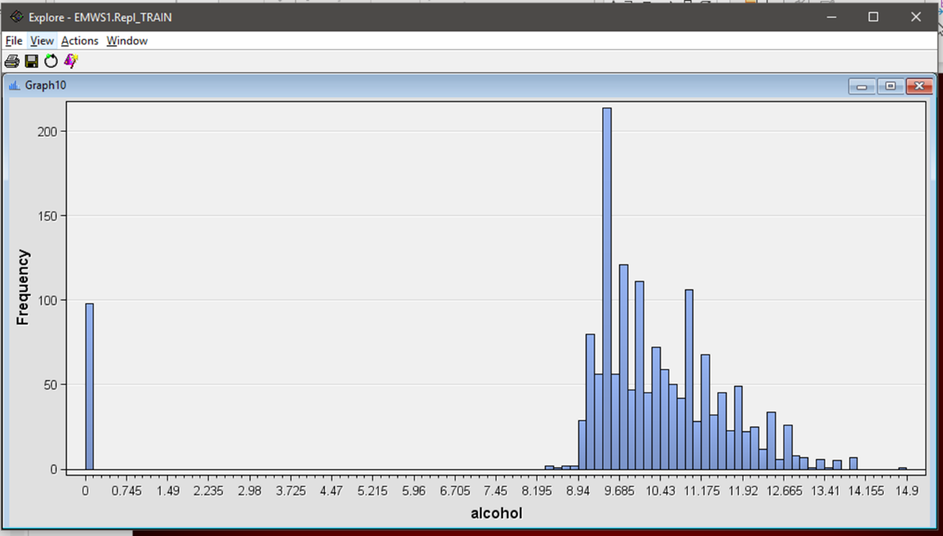

*Figure 7 Example exploration of alcohol attributes.*

Figure 7 shows exploration on alcohol attribute. There are 98 sample with value of zero while most of them are ranging from 8 until 15.

1. Attribute: Citric Acid

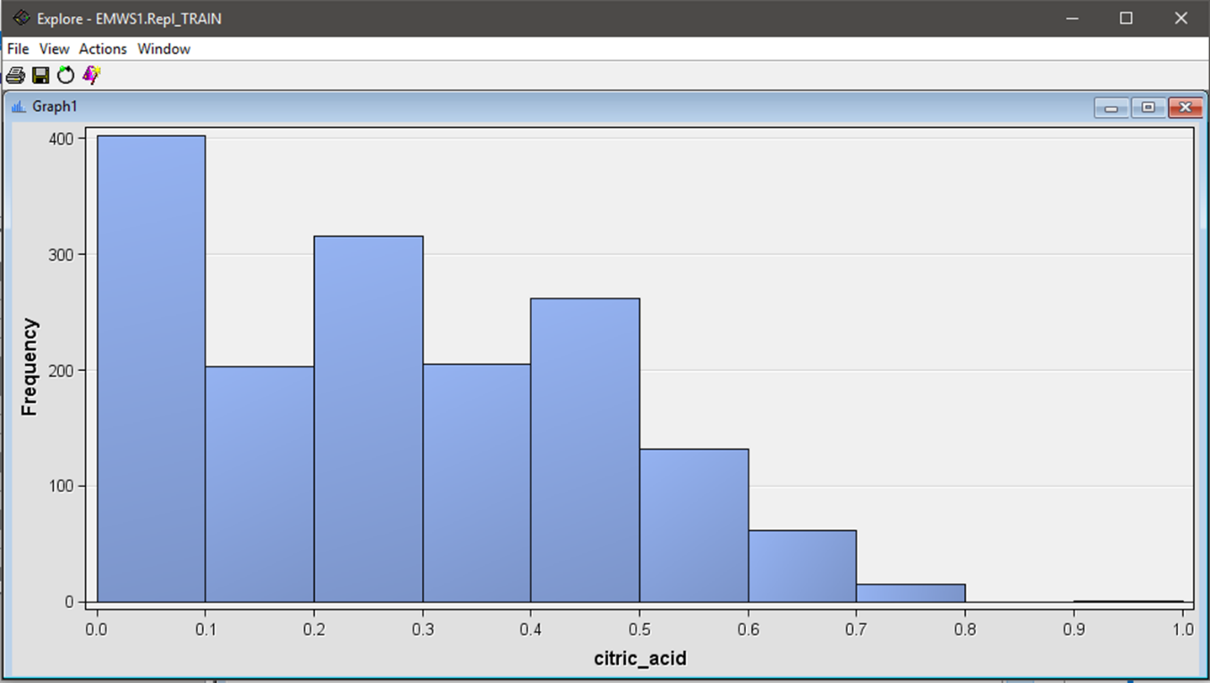

*Figure 8 Example exploration of citric acid attributes.*

Figure 8 shows exploration on citric acid attribute. From the histogram, we can learn that the value of citric acid of the sample test are mostly around 0.0 until 0.1.

1. Attribute: Density

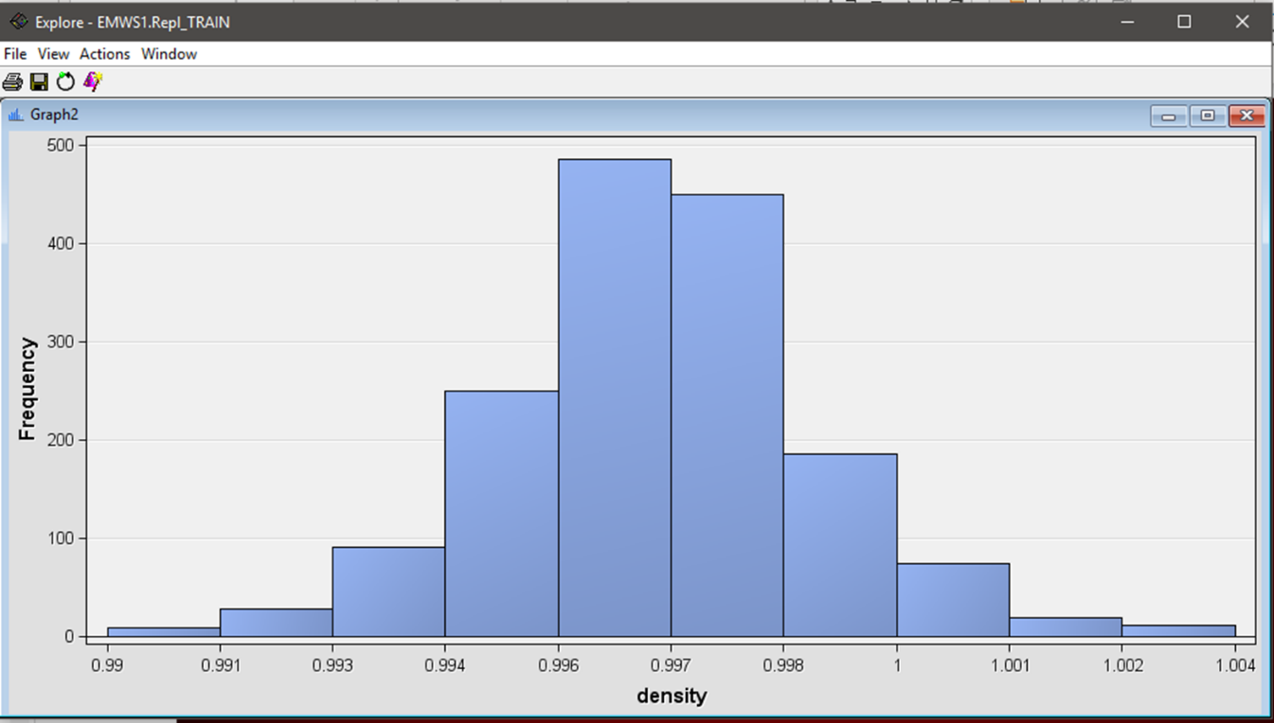

*Figure 9 Example exploration of density attributes.*

Figure 9 shows exploration on density attribute. As we can see, the density of the alcohol is almost the same with only difference in 0.001

1. Attribute: Fixed Acidity

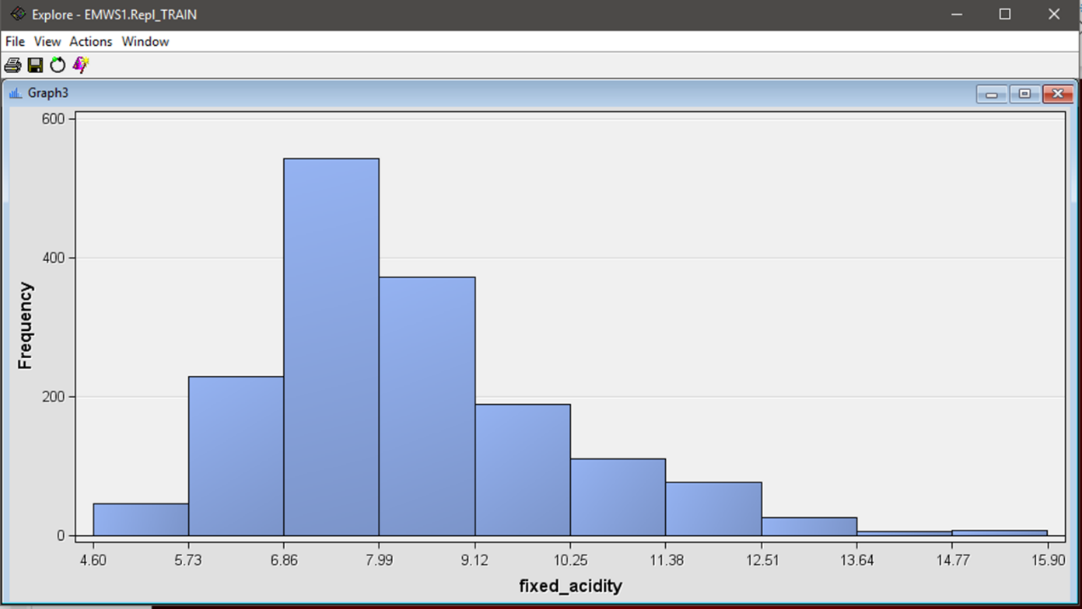

*Figure 10 Example exploration of fixed_acidity attributes.*

Figure 10 shows exploration on fixed_acidity attributes. The data is ranging from 4.6 until 15.9 and most of the sample has fixed_acidity from 6.86 to 7.99.

1. Attribute: Free Sulphur Dioxide

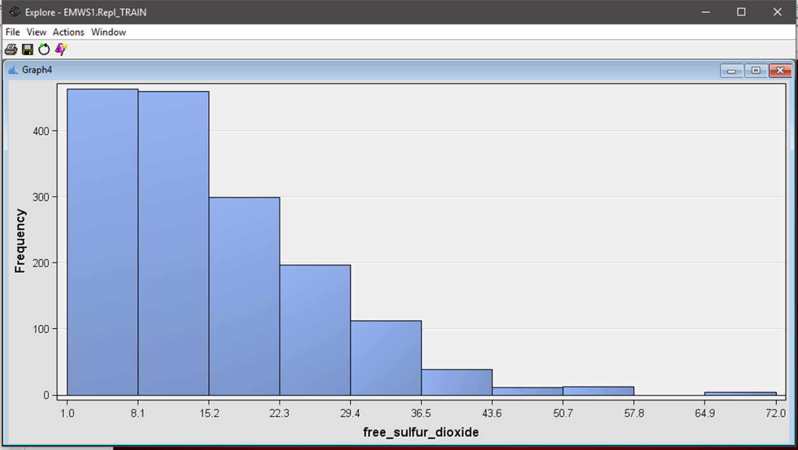

*Figure 11 Example exploration of fixed_sulphur_dioxide attributes.*

Figure 11 shows exploration on *fixed_sulphur_dioxide* attributes. From the histogram, the sample has fixed most sulphur dioxide from 1.0 until 15.2 while only small proportion of them has value of 64.9 until 72.0

1. Attribute: pH

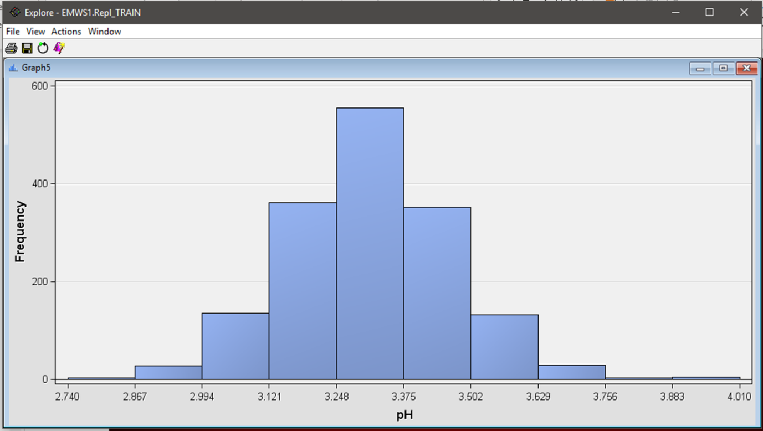

*Figure 12 Example exploration of pH attributes.*

Figure 12 shows exploration on *pH* attributes. The *pH* of the red wine mostly is 3.

1. Attribute: Residual Sugar

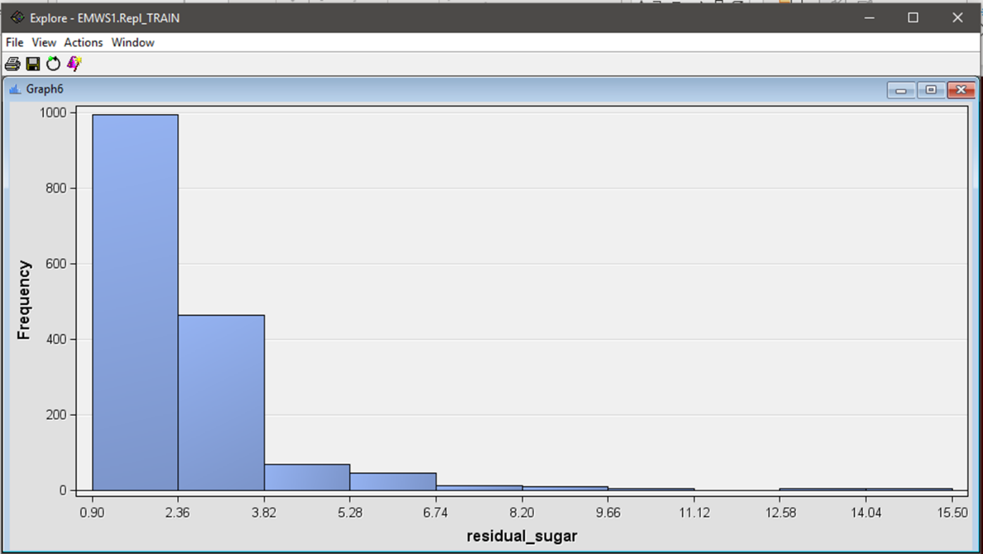

*Figure 13 Example exploration of residual_sugar attributes.*

Figure 13 shows exploration on *residual_sugar* attributes. The red wine sample has most distribution of residual_sugar of 0.9 until 2.36 while there are one or two cases with high residual_sugar of 12.58 until 15.50.

1. Attribute: Sulphates

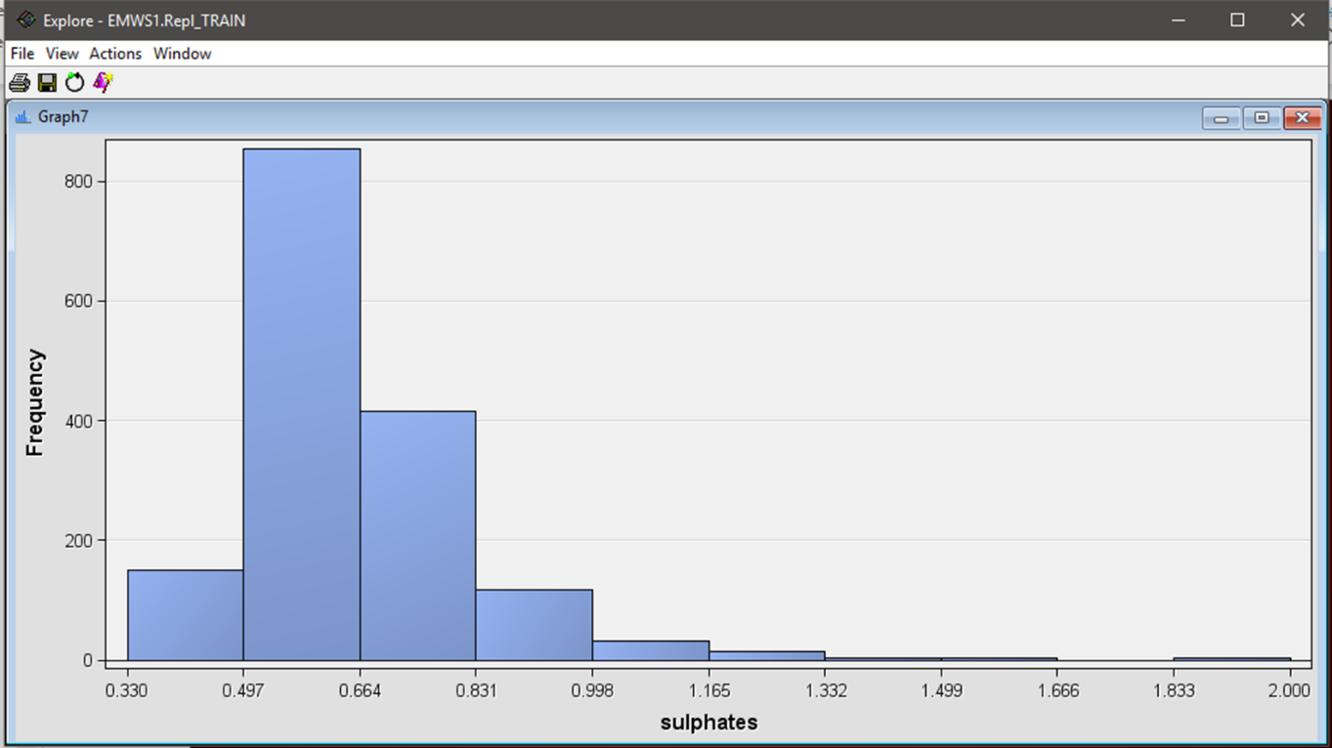

*Figure 14 Example exploration of sulphates attributes.*

Figure 14 shows exploration on *sulphates* attributes. We can conclude that most of the sulphates value of the red wine sample ranging from 0.497 until 0.664.

1. Attributes: Total Sulphur dioxide

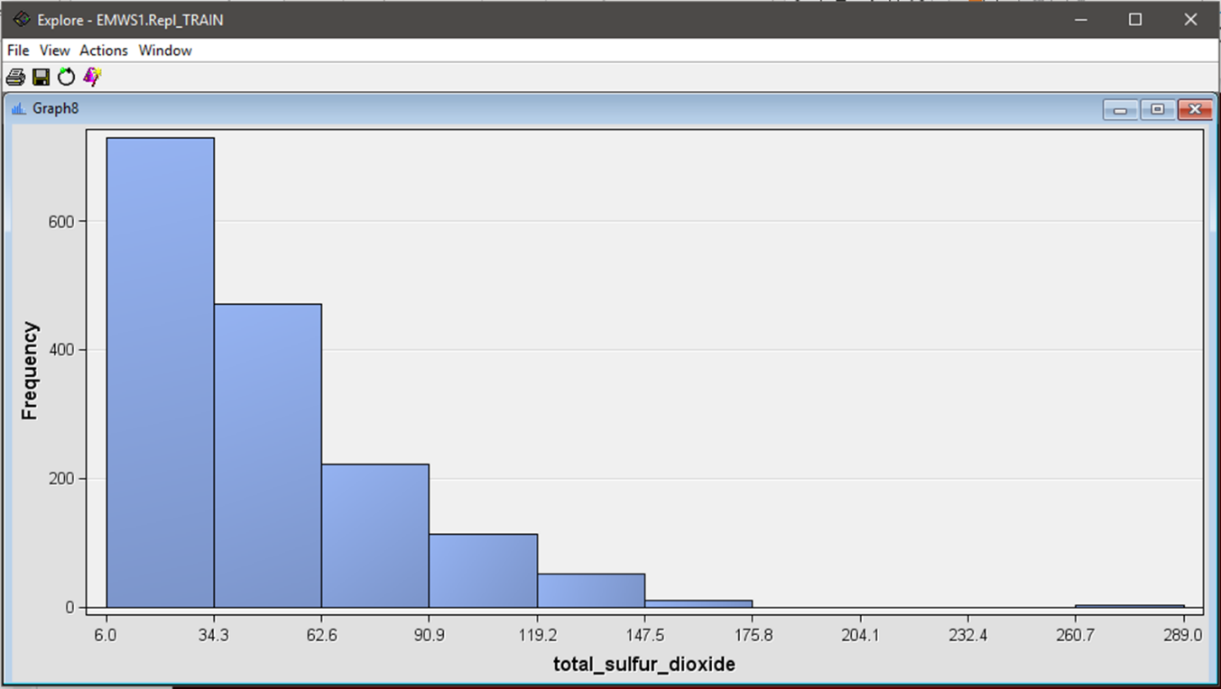

*Figure 15 Example exploration of total_sulphur_dioxide attributes.*

Figure 15 shows exploration on *total_sulphur_dioxide* attributes ranging from six until 289.

1. Attribute: Volatile Acidity

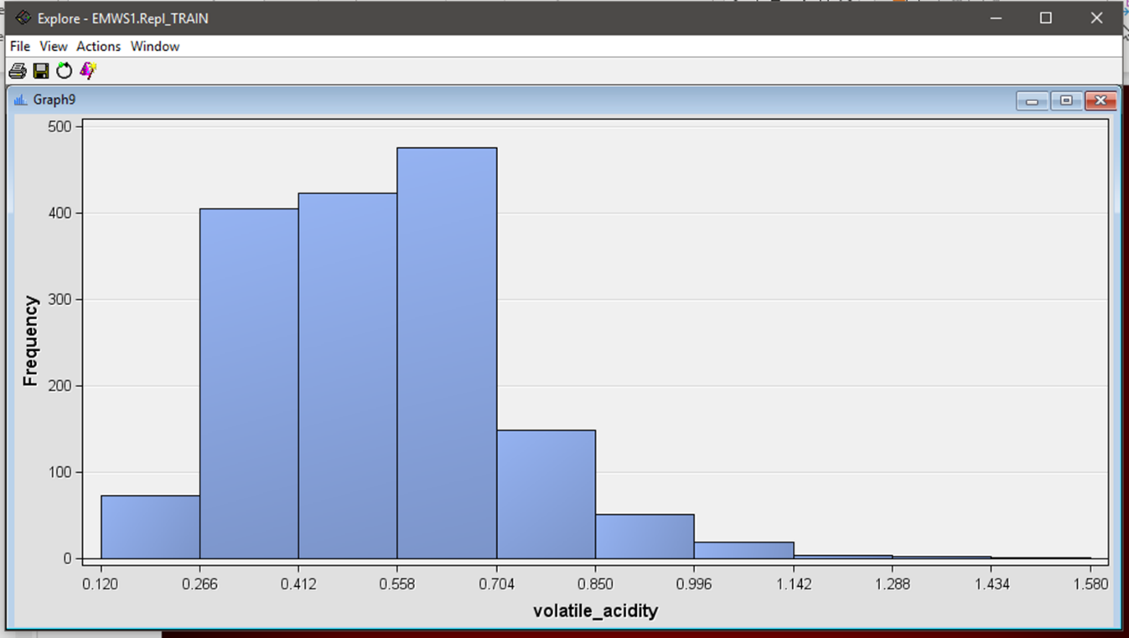

*Figure 16 Example exploration of volatile_acidity attributes.*

Figure 16 shows exploration on *volatile_acidity* attributes. From the histogram, we can see that most of the red wine sample has almost the same volatile_acidity.

1. **Replacement**

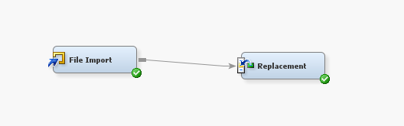

**4.1 Exporting data to replacement**

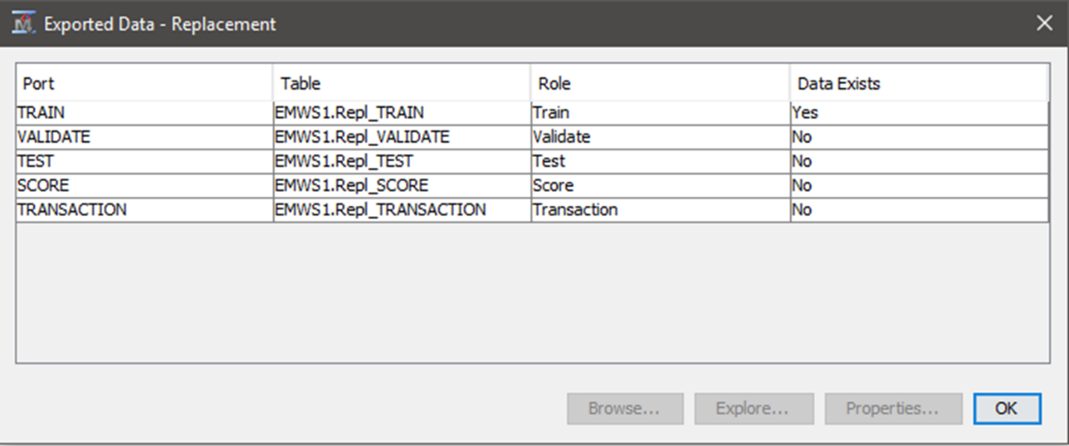

* 1. **Explore train in replacement**

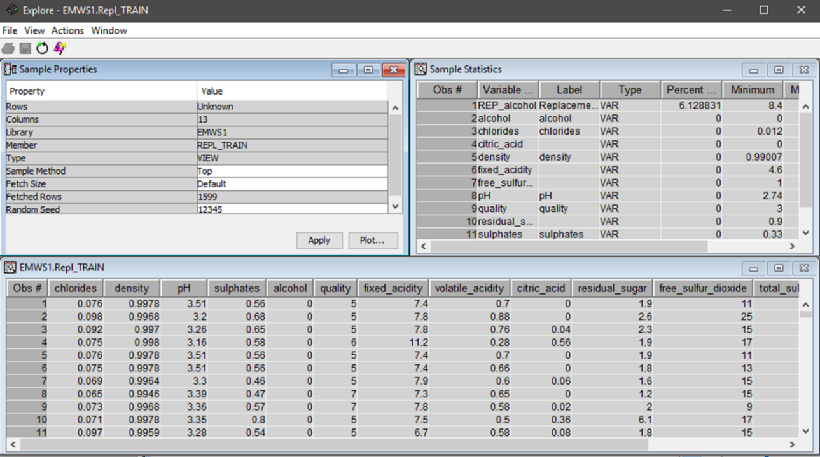

* 1. **Replacing score value to missing**

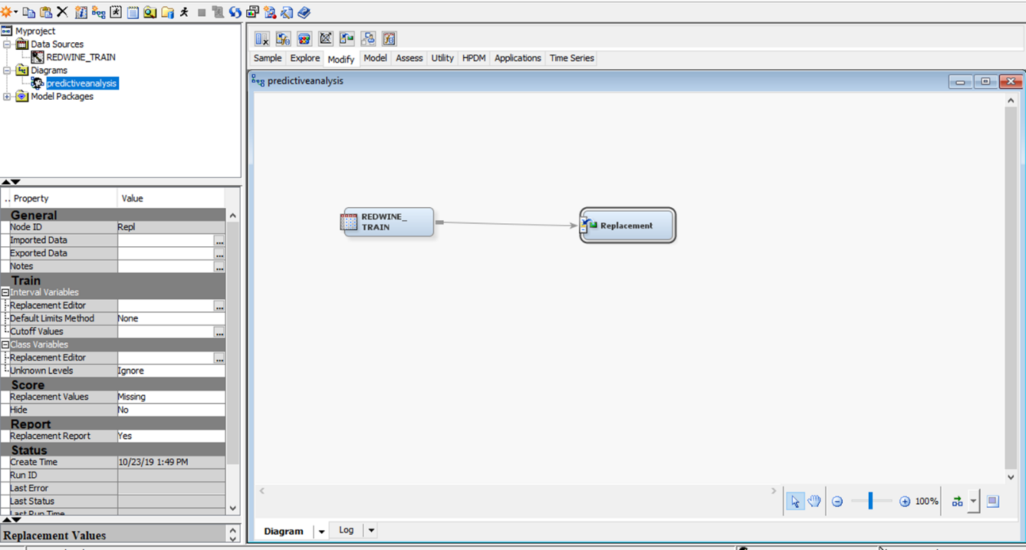

* 1. **Replacing null to 1 using replacement method**

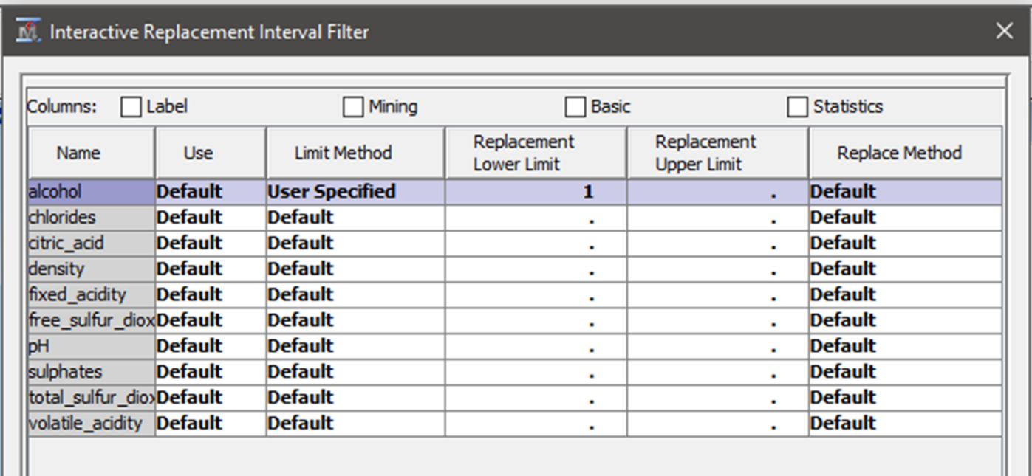

* 1. **Null value (0) converted to (.)**

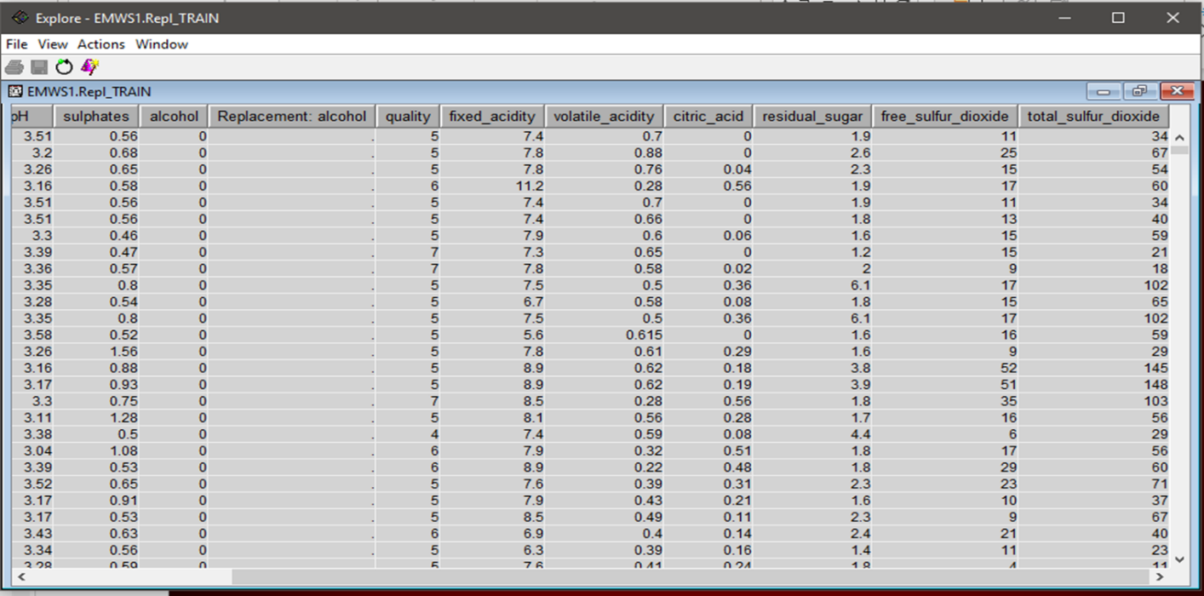

* The replaced zero value is shown by a dot(.)
* It is indicating a missing value
  1. **Replacement (0) to (.) missing summary**

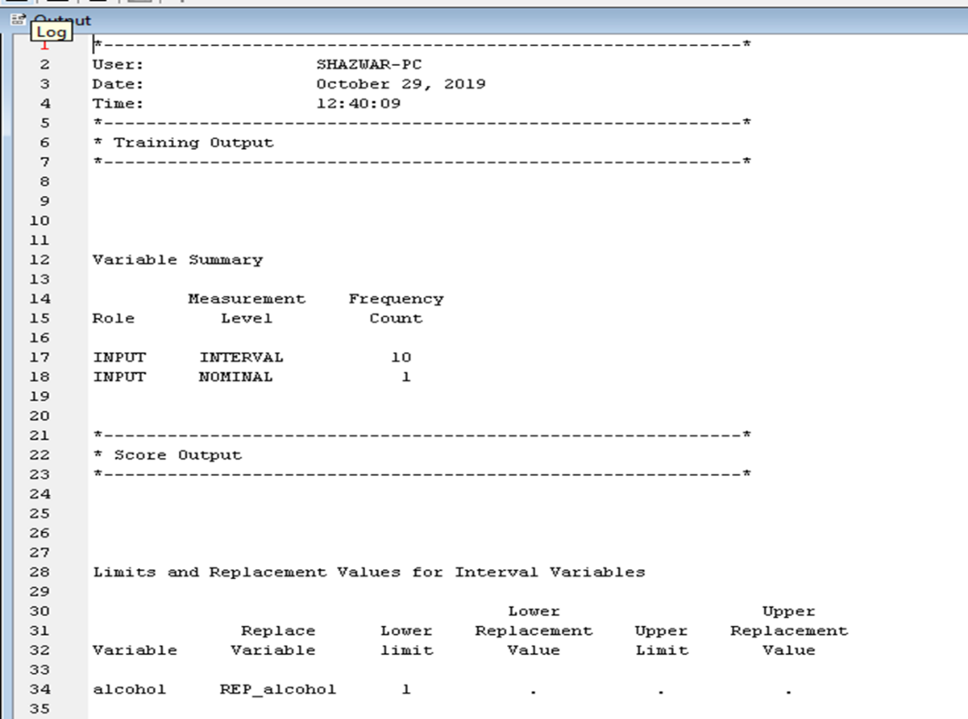

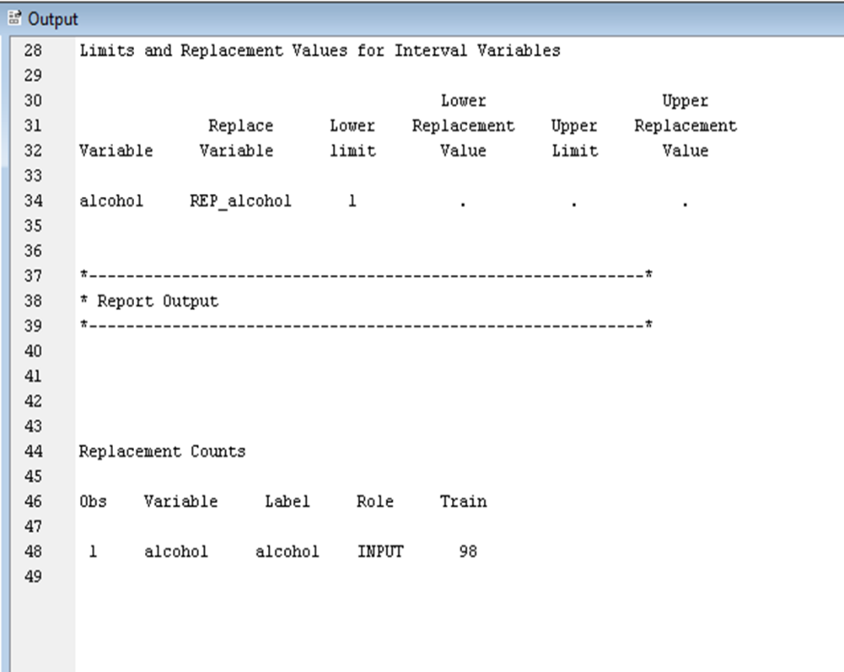

* 1. **Creating histogram after replacement**

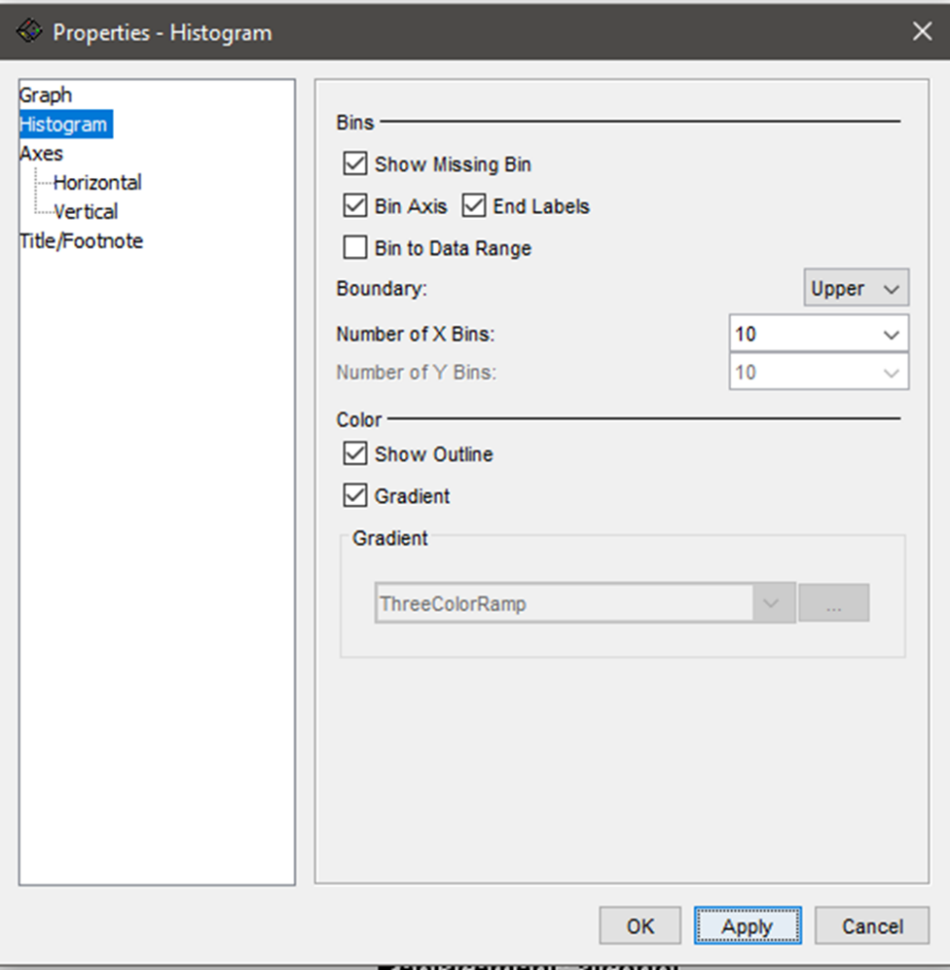

* 1. **Plotting histogram**

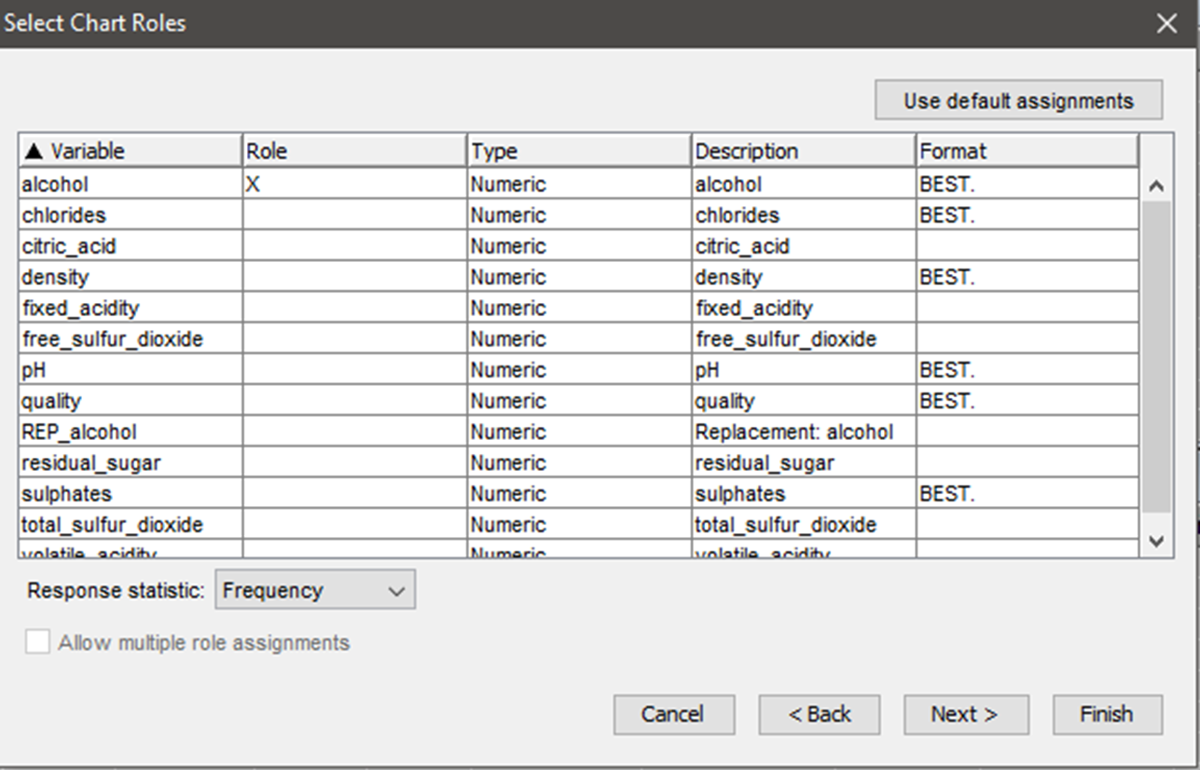

* 1. **Histogram after replacement**

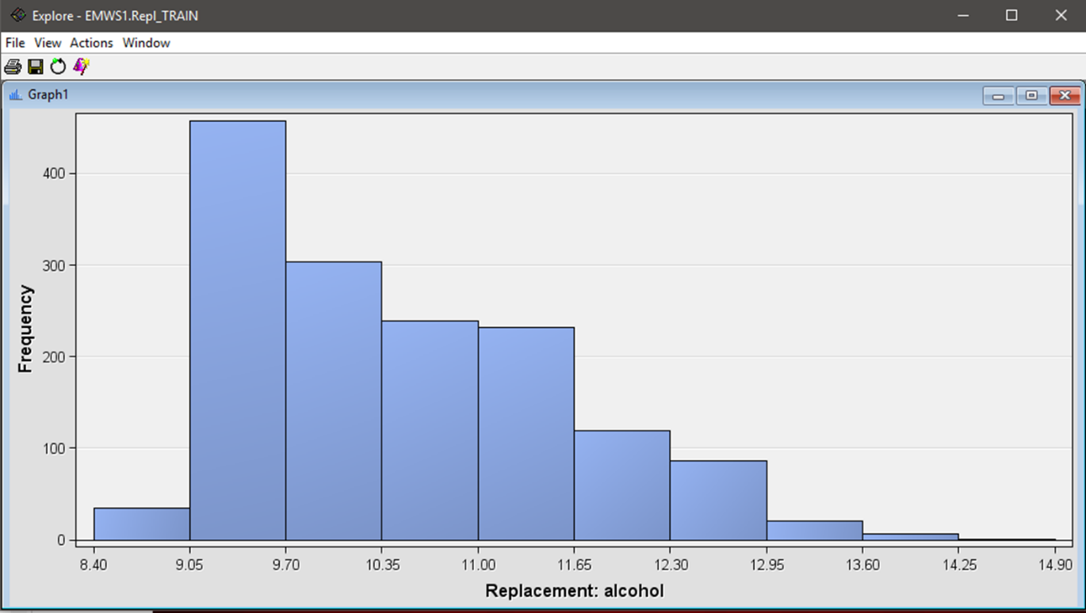

* 1. **Histogram after replacement with missing bins**

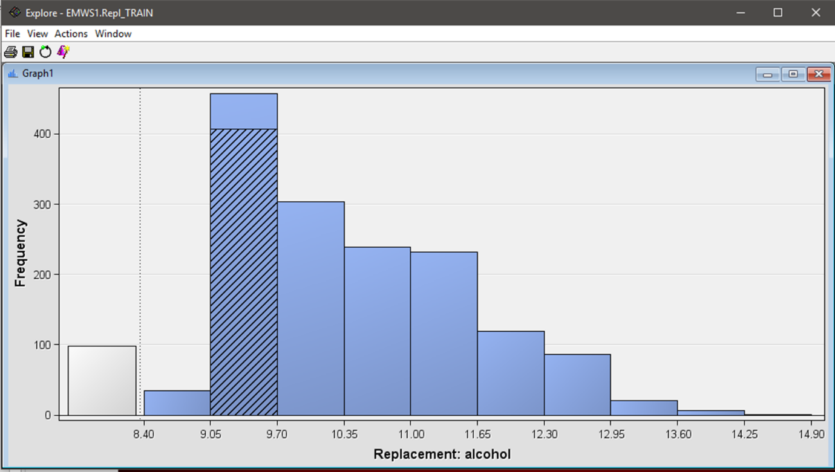

From both histograms, we can see that 98 sample of the red wine was missing from the dataset.

1. **Explore Part II – Cluster**

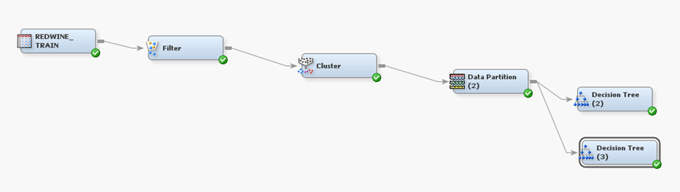

*Current process diagram*

**5.1 Results from the Cluster node**

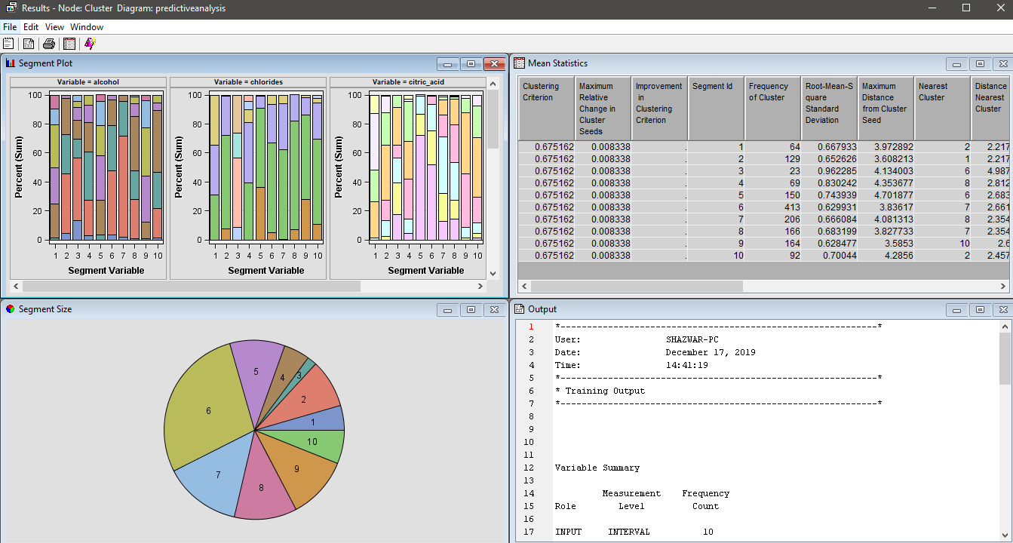

*Diagram shows the result when cluster node run*

**5.2**

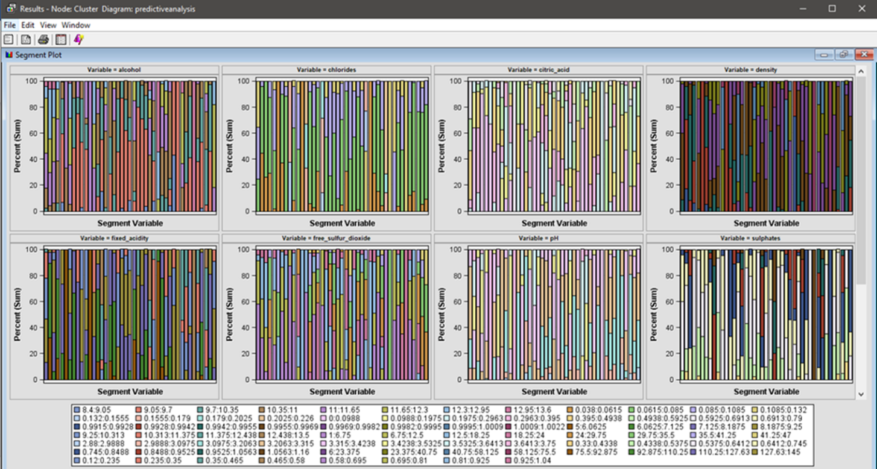

*Diagram shows the segment plot*

**5.3**

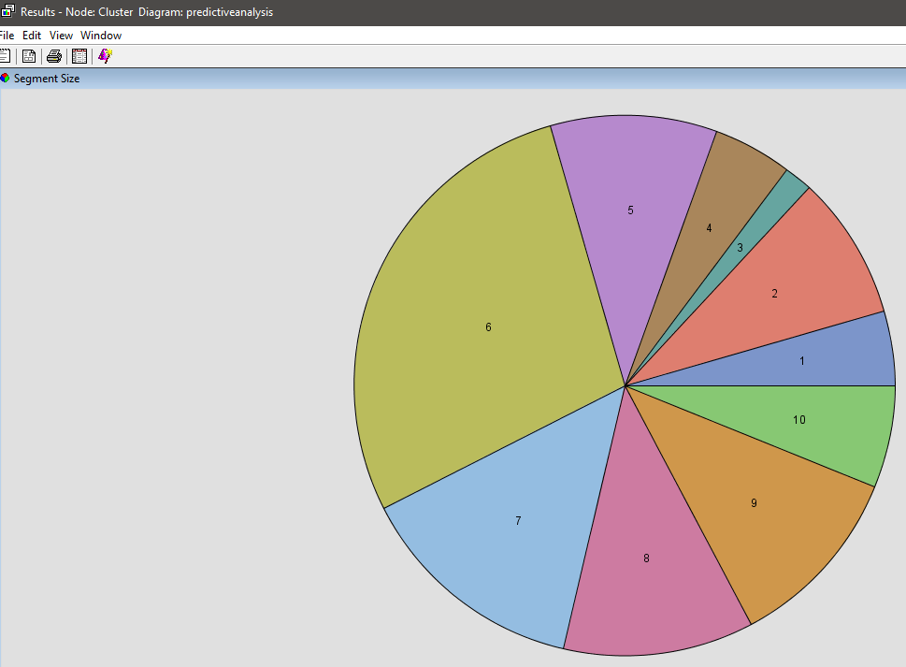

*Diagram shows the segment size*

**5.4**

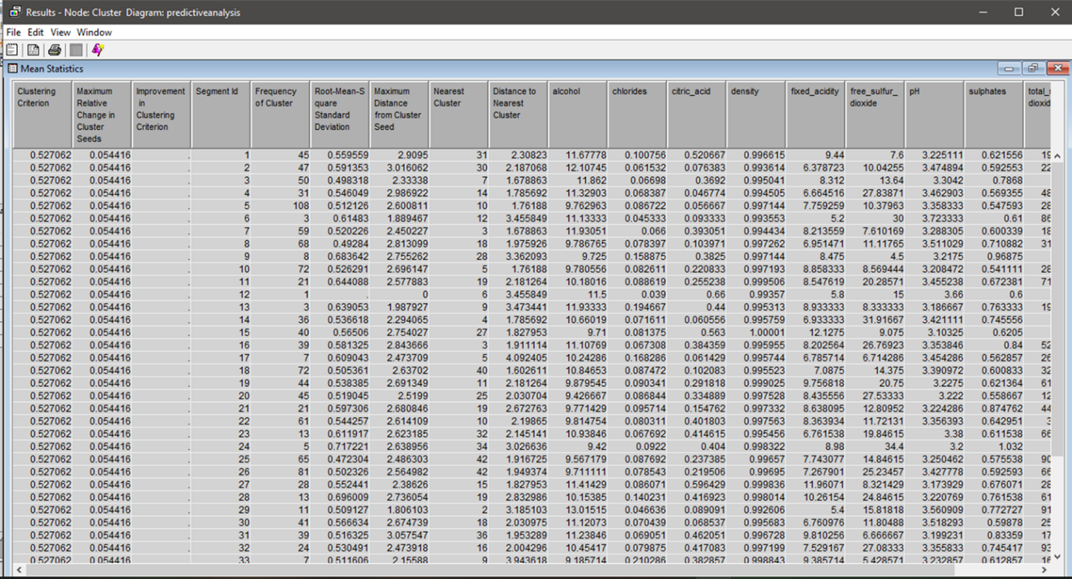

*Diagram shows the mean statistics*

**5.5 Output summary**

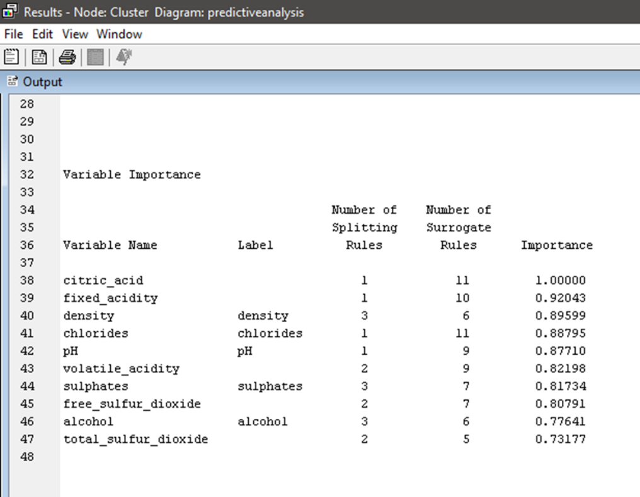

*Diagram shows the output summary*

1. **Data Partition**

In order to predict a target value from a set on input values, we need a set of training data that could easily generate models accurately. Select the Sample tool tab and drag the Data Partition tool into the diagram workspace.

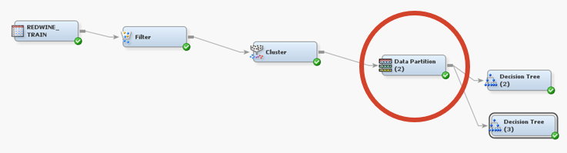

*Current process diagram*

**6.1**

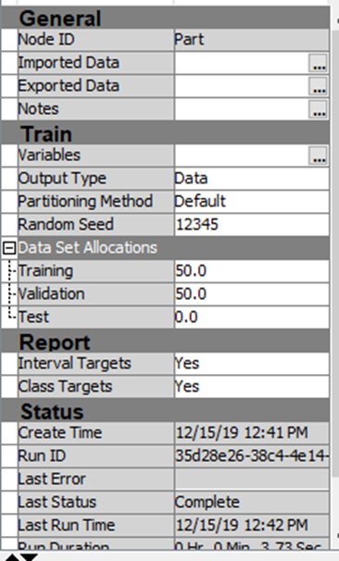

*Attribute table of data partition node*

Select the Data Partition node and examine its Properties panel. Select the fraction of data devoted to the Training, Validation and Test. More data devoted to training results in more stable predictive models, but less stable model assessment. Also, the Test partition is used only for calculating fit statistics after the modelling and model selection is complete. Next, type 50 as the Training value, type 50 as Validation value, and type 0 as the Test value in the Data Partition node.

**6.2**

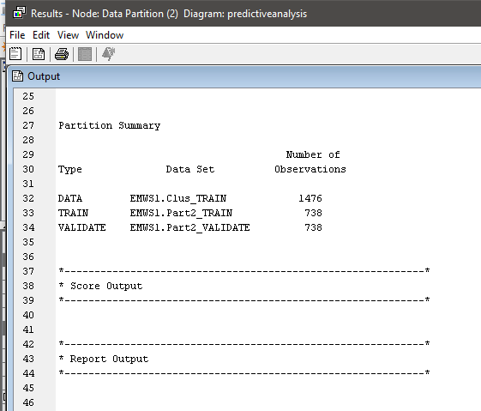

Right click at Data Partition node and select Run. Then, choose YES in the confirmation window. Next, select Results in the Run status. The results show a basic metadata summary of the raw data that feeds the node and the important part is, a frequency table that shows the distribution of the target variable which is Order_Priority in the raw, training and validation data sets. Next, we are ready to build a predictive model.

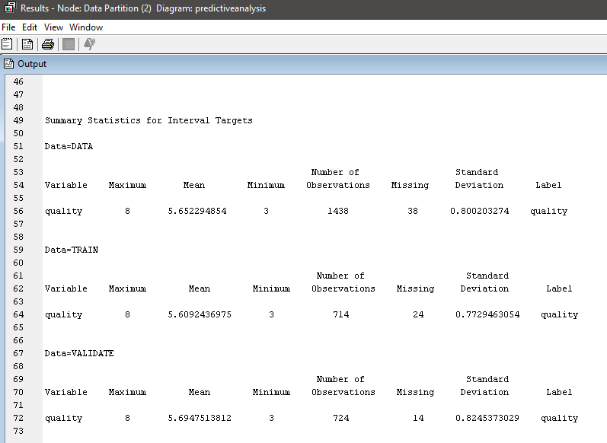

*The results of the data partition node*

**7.0 Decision tree**

**7.L Branch Tree: 2**

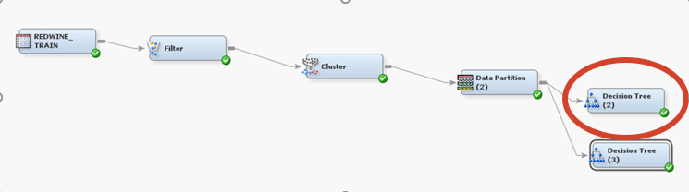

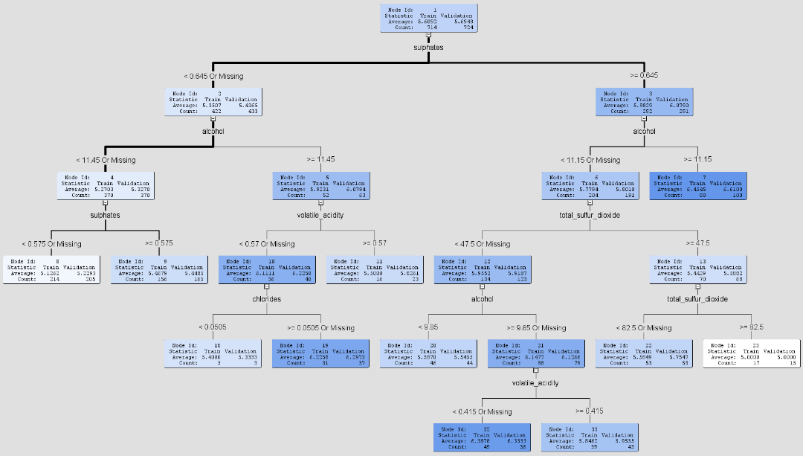

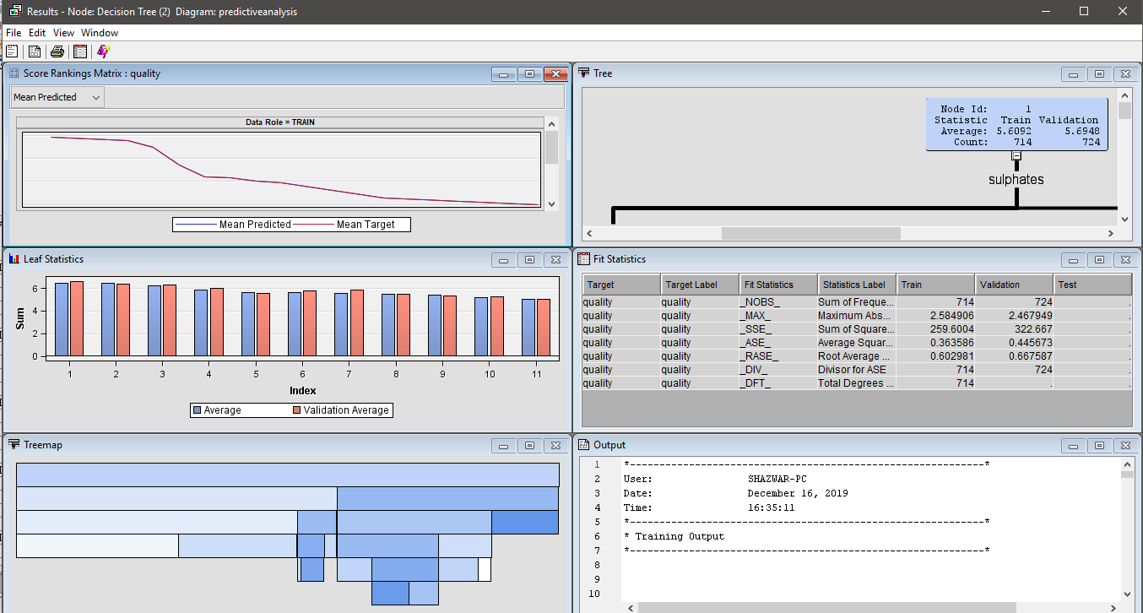

*Figure 13: The diagram with highlighted on decision tree (2) node*

The results contain a variety of diagnostic plots and tables, including a cumulative lift chart, a tree map and a table of fit statistics. It also shows in the results vary with the measurement level of the target Order Priority variable.

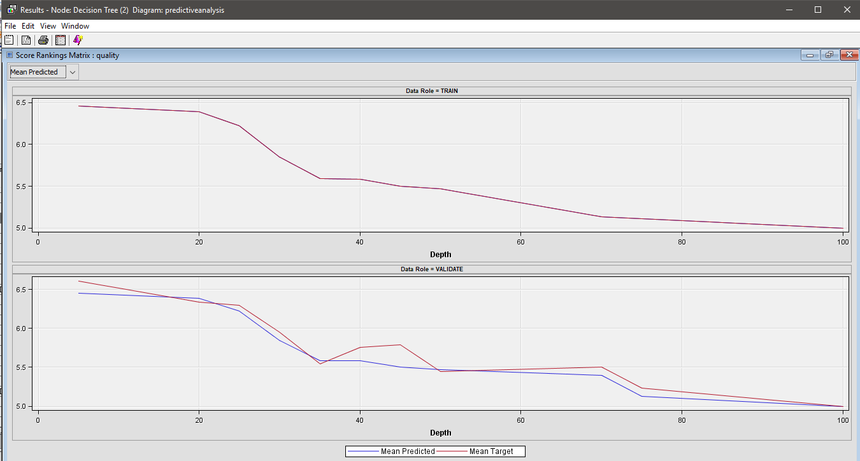

***The score ranking matrix***

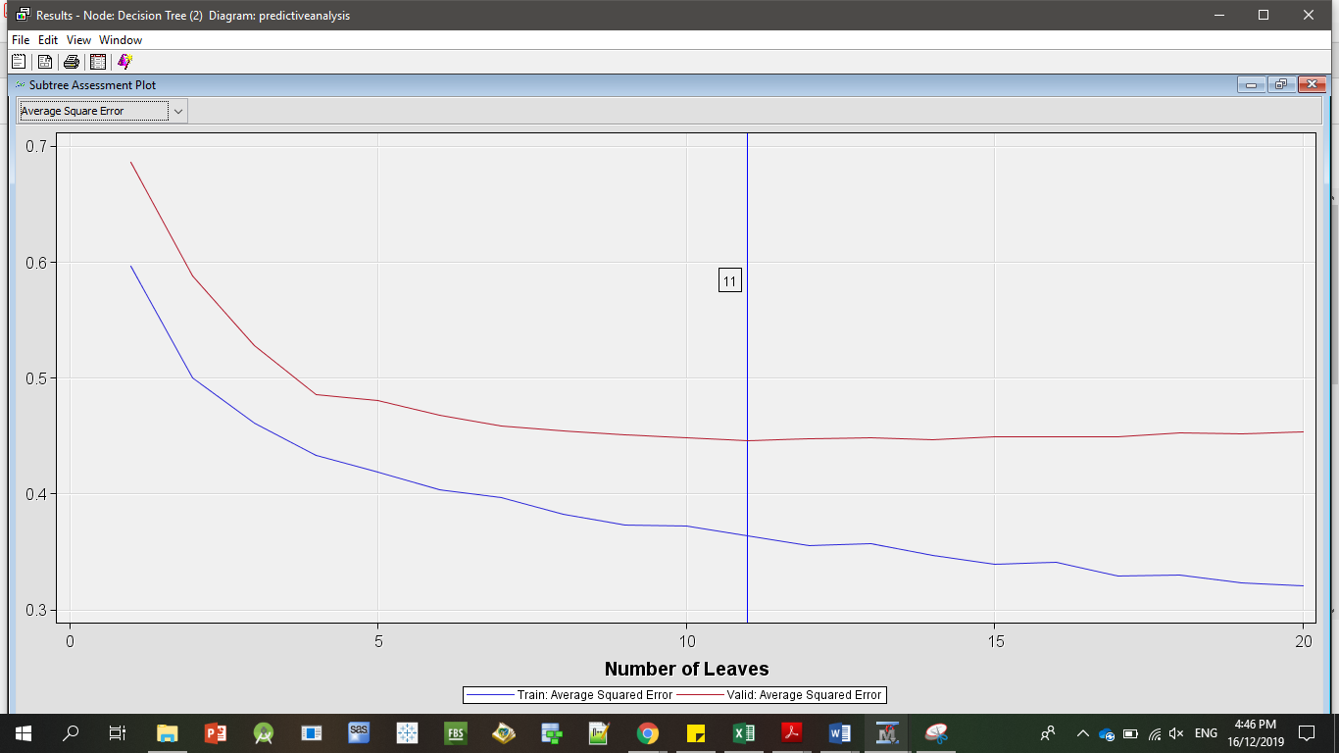

***The number of leaves generated for this decision tree is 11***

The plot shows the Average Square Error corresponding to each subtree as the data is sequentially split. It looks similar the last one that generated with the Interactive Design Tree tool and it confirms the suspicions about the optimality of the 6-leaves tree. The performance become monotonically better as the tree becomes more complex. It also shows the evidence of model overfitting. Over the range 1-2 leaves, the precision of the model improves with the increase in complexity. A marginal increase in complexity over this range results in better accommodation of the systematic variation or signal in data.

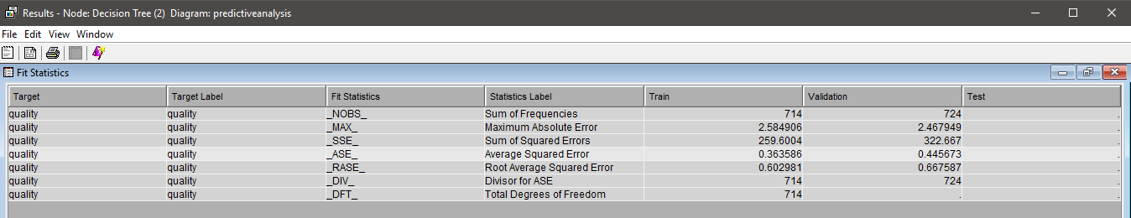

**The Average Square Error for the validation data for this decision tree is 0.445673**

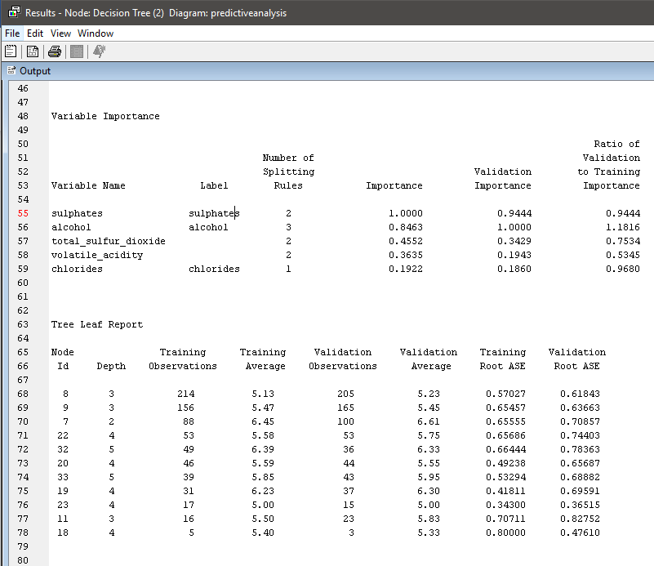

**7.2 Decision Tree**

**Branch Tree: 3**

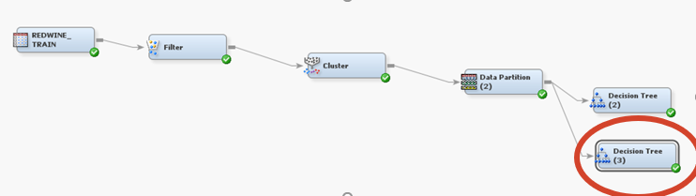

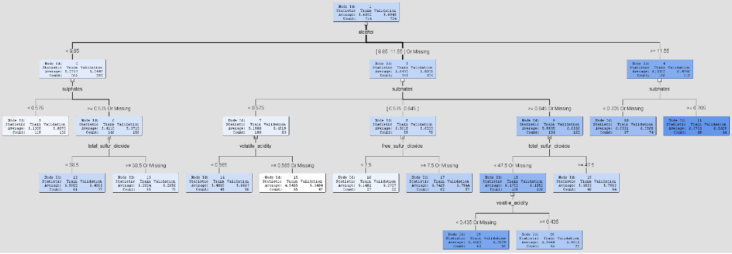

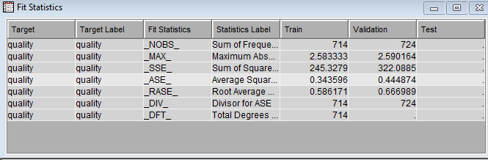

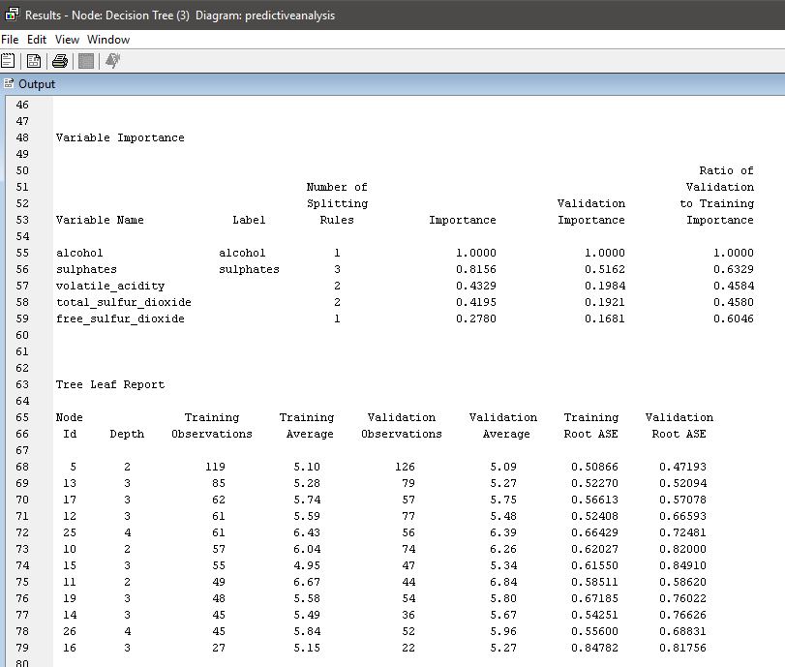

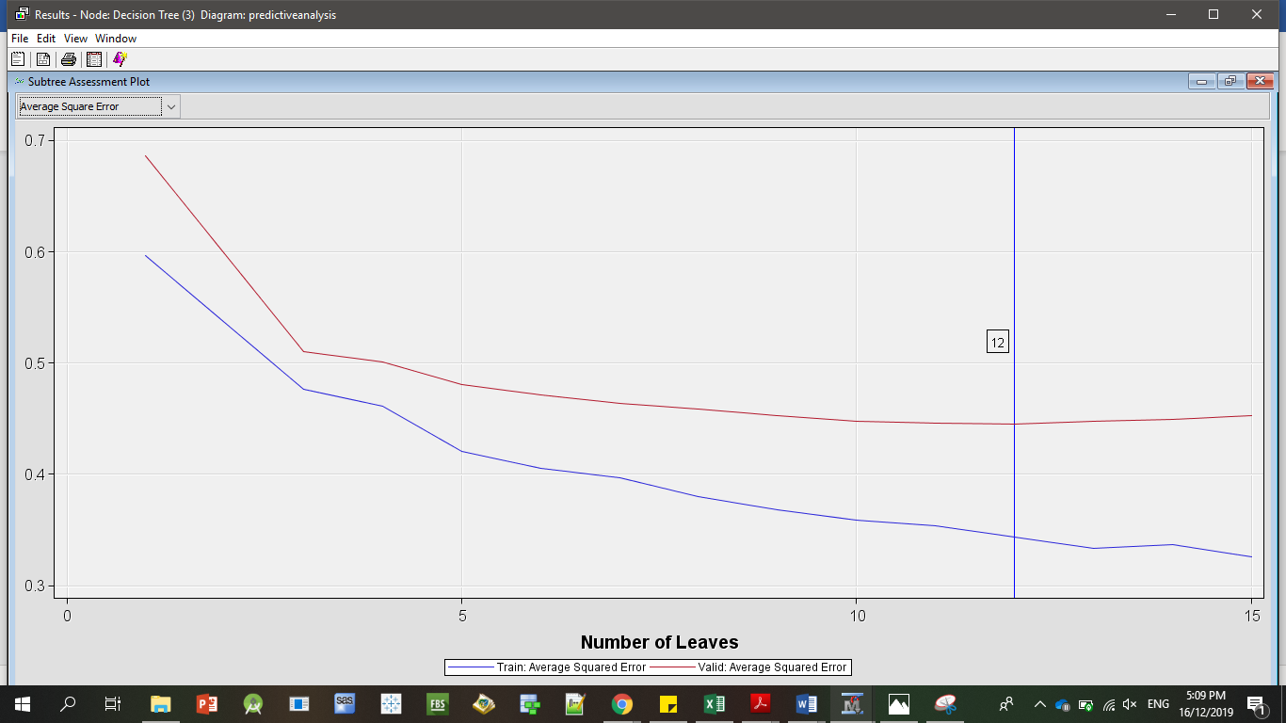

***The number of leaves generated for this decision tree is 11***

**8.0 Model Comparison**

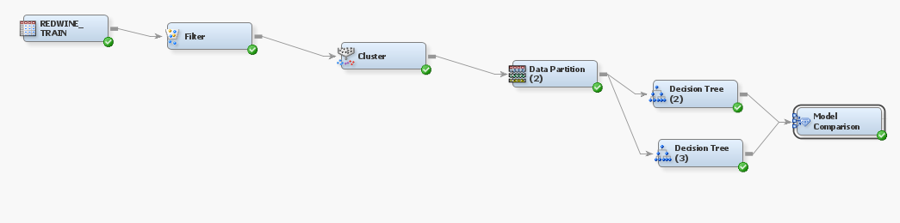

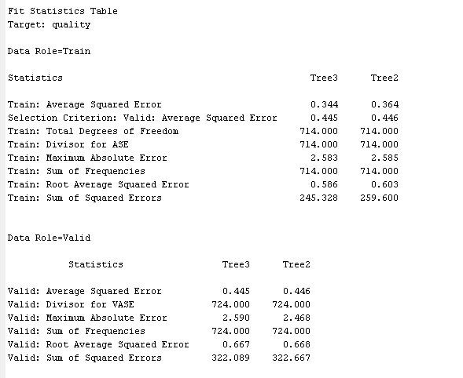

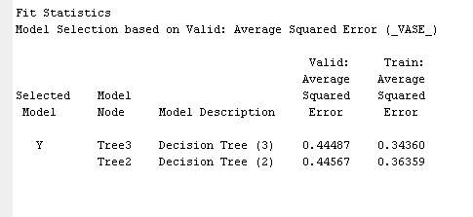

**9.0 References**

SAS Institute Inc. (2017). Introduction to SEMMA. Retrieved from https://documentation.sas.com/?docsetId=emref&docsetTarget=n061bzurmej4j3n1jnj8bbjjm1a2.htm&docsetVersion=14.3&locale=en

Sakar, C. O., Polat, S. O., Katircioglu, M., & Kastro, Y. (2018). Real-time prediction of online shoppers’ purchasing intention using multilayer perceptron and LSTM recurrent neural networks. *Neural Computing and Applications*, *0*, 1–16. https://doi.org/10.1007/s00521-018-3523-0

SASInstituteInc. (2009). *Getting Started with SASEnterprise Miner 6.1*. Cary, NC, USA.